Nathan Gaffney

22-October-2014

CST-183-FA110-14FA-COURSE

This program will create a basic GUI and prompt the user for data related to a business trip and determine the amount owed, if any.

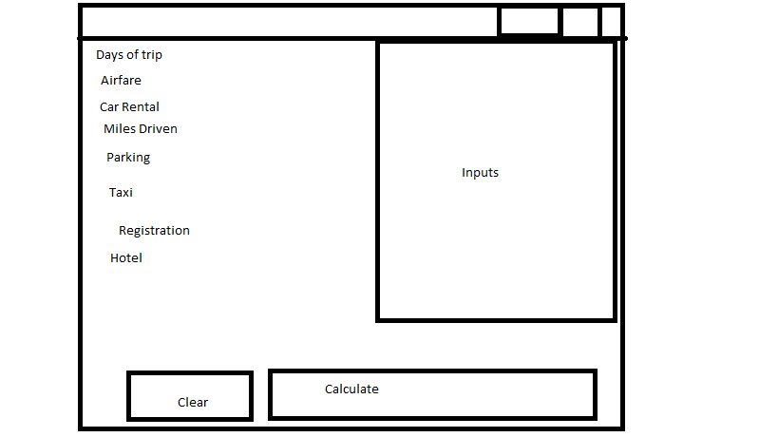

Start

btnClear

btnCalc

lblDays

lblAir

lblRental

lblMiles

lblParking

lblTaxi

lblConference

lblLodging

txtDays

txtAir

txtRental

txtMiles

txtParking

txtTaxi

txtConference

txtLodging

//Make window and panes

//Add to panels

calcTotals()

Total:

Allowed = 17* days + 10*days + 20*days + 95 * days +

If private car used .27*miles

Else + 0

Spent = airfare + lodging*days + taxi + parking + rental

Clear()

//Clear all text fields

Step 3.

/*---------------------  
Created by: NAthan Gaffney  
22-October-2014  
JAVA PROGRAMMING - CST-183-FA110-14FA-COURSE  
This class will create a reimbursement report.  
Errors Handled:   
Dependencies: None:  
buildContentPane  
buildPanButtons  
clearTexts  
calcTotals  
----------------------*/  
import java.text.DecimalFormat;  
import javax.swing.*;  
import java.awt.*;  
import java.awt.event.*;  
import javax.swing.JOptionPane;  
public class TravelExpenses extends JFrame  
{  
 final int WINDOW_WIDTH = 325;  
 final int WINDOW_HEIGHT = 300;  
 //--------------------  
 //Expenses WIndow  
 //Containers  
 private Container contentPane;  
 //Panels   
 private JPanel panButtons;  
 //Labels  
 private JLabel lblDays;  
 private JLabel lblAirfare;  
 private JLabel lblRental;  
 private JLabel lblMiles;  
 private JLabel lblParking;  
 private JLabel lblTaxi;  
 private JLabel lblConference;  
 private JLabel lblLodging;  
 //Text Fields  
 private JTextField txtDays;  
 private JTextField txtAirfare;  
 private JTextField txtRental;  
 private JTextField txtMiles;  
 private JTextField txtParking;  
 private JTextField txtTaxi;  
 private JTextField txtConference;  
 private JTextField txtLodging;  
 //Buttons  
 private JButton btnClear;  
 private JButton btnCalc;  
 //End Expenses WIndow  
 //---------------------  
  
 public TravelExpenses()  
 {  
 //Create Window  
 setTitle("Travel Expenses");  
 setSize(WINDOW_WIDTH,WINDOW_HEIGHT);  
 setDefaultCloseOperation(JFrame.EXIT_ON_CLOSE);  
   
 //Content Pane  
 buildContentInfo();  
 add(contentPane,BorderLayout.CENTER);  
 //BUTTONS!!!  
 buildPanButton();  
 add(panButtons,BorderLayout.SOUTH);  
 }  
 /**This method will create the main content pane*/  
 private void buildContentInfo()  
 {  
 contentPane = new JPanel();  
 contentPane.setLayout(new GridLayout(8,2));  
 setLayout(new BorderLayout());  
 lblDays = new JLabel("Number of days on Trip:");  
 lblAirfare = new JLabel("Amount of Airfare:");  
 lblRental = new JLabel("Amount of Car Rental:");  
 lblMiles = new JLabel("Miles Driven:");  
 lblParking = new JLabel("Parking Fees:");  
 lblTaxi = new JLabel("Taxi Fees:");  
 lblConference = new JLabel("Conference Registration:");  
 lblLodging = new JLabel("Lodging charges per night:");  
 txtDays = new JTextField(10);  
 txtAirfare = new JTextField(10);  
 txtRental = new JTextField(10);  
 txtMiles = new JTextField(10);  
 txtParking = new JTextField(10);  
 txtTaxi = new JTextField(10);  
 txtConference = new JTextField(10);  
 txtLodging = new JTextField(10);  
 contentPane.add(lblDays);  
 contentPane.add(txtDays);  
 contentPane.add(lblAirfare);  
 contentPane.add(txtAirfare);  
 contentPane.add(lblRental);  
 contentPane.add(txtRental);  
 contentPane.add(lblMiles);  
 contentPane.add(txtMiles);  
 contentPane.add(lblParking);  
 contentPane.add(txtParking);  
 contentPane.add(lblTaxi);  
 contentPane.add(txtTaxi);  
 contentPane.add(lblConference);  
 contentPane.add(txtConference);  
 contentPane.add(lblLodging);  
 contentPane.add(txtLodging);   
 }  
 /**This method will create the bottom panel*/  
 private void buildPanButton()  
 {  
 panButtons = new JPanel();  
 panButtons.setLayout(new FlowLayout());  
 btnClear = new JButton("Clear");  
 btnClear.addActionListener(new ButtonListener());  
 btnCalc = new JButton("Calculate");  
 btnCalc.addActionListener(new ButtonListener());  
   
 //add buttons  
 panButtons.add(btnClear);  
 panButtons.add(btnCalc);  
 }  
 /**This method will clear the text fields  
 */  
 private void clearText()  
 {  
 txtDays.setText("");  
 txtAirfare.setText("");  
 txtMiles.setText("");  
 txtParking.setText("");  
 txtTaxi.setText("");  
 txtRental.setText("");  
 txtConference.setText("");  
 txtLodging.setText("");  
 }  
 /**This method will calculate the totals.  
 It will then display them in a dialog box.  
 */  
 private void calcTotals()  
 {  
 int intDays = Integer.parseInt(txtDays.getText());  
 double dblAirfare = Double.parseDouble(txtAirfare.getText());  
 double dblRental = Double.parseDouble(txtRental.getText());  
 double dblMiles = Double.parseDouble(txtMiles.getText());  
 double dblParking = Double.parseDouble(txtParking.getText());  
 double dblTaxi = Double.parseDouble(txtTaxi.getText());  
 double dblConference = Double.parseDouble(txtConference.getText());  
 double dblLodging = Double.parseDouble(txtLodging.getText());  
 double travel;  
 double total;  
 double allowable;  
 double returned;  
 String spentStatus;  
 DecimalFormat dollar = new DecimalFormat("$0.00");  
   
 if(dblRental !=0)  
 {  
 travel = 0.27 * dblMiles;  
 }  
 else  
 {  
 travel = 20.0*intDays;  
 }  
   
 total = dblAirfare + dblRental + dblParking +   
 dblTaxi + dblConference + dblLodging*intDays;  
 allowable = 17.0*intDays + 10.0*intDays + travel +  
 95.0*intDays;   
   
 if(total <= allowable)  
 {  
 spentStatus = "You saved the company: " +  
 dollar.format(allowable - total);  
 }  
 else  
 {  
 spentStatus = "You owe: " +  
 dollar.format(total-allowable);  
 }  
   
 JOptionPane.showMessageDialog(null,"Total Expense: " + dollar.format(total) + "\n"  
 +"Allowable Expenses: " + dollar.format(allowable) + "\n"  
 +spentStatus);  
   
 }  
 private class ButtonListener implements ActionListener  
 {  
 public void actionPerformed (ActionEvent event)  
 {  
 String whichButton = event.getActionCommand();  
 if(whichButton.equals("Clear"))  
 {  
 clearText();  
 }  
 else if (whichButton.equals("Calculate"))  
 {  
 calcTotals();  
 }  
 }  
 }  
 public static void main(String[] args)  
 {  
 TravelExpenses travel = new TravelExpenses();  
 travel.setVisible(true);  
 }  
  
}

